THE INSILICO LAB
3-Week Virtual Training in CADD
Week 2

Drug-likeness Screening & Molecular Docking

Participant Name  Amarachi Eze_________________ | Date Submitted  31st May 2026______________________
Cohort / Batch  4___________________________ | Email Address  aeamarachi@gmail.com______________

📋 Before You Begin
This is Week 2 of The Insilico Lab Training Programme. Ensure you have completed Week 1 (Tasks 1–3) before starting, as this assignment builds directly on those results.

TASK 1 | Drug-likeness Screening

Objective: To demonstrate the ability to perform drug-likeness screening of selected compounds.

▸ Compounds for This Task

🌿  Erlotinib | 🌿  Gefitinib | 💊  Lapatinib

▸ Task Description
1 | Go to PubChem (https://pubchem.ncbi.nlm.nih.gov) and search for each compound: Erlotinib, Gefitinib, and Lapatinib.
2 | Record the PubChem CID and the canonical SMILES for each compound in the table below.
3 | Download the SDF file for each compound from PubChem (3D Conformer preferred).
4 | Open the SDF files in PyMOL to visualize each compound structure. Take a screenshot for each.
5 | Go to SwissADME (http://www.swissadme.ch) and paste all three SMILES strings into the input field.
6 | Run the analysis and record the Lipinski Rule of Five results for each compound.
7 | Take a screenshot of the SwissADME results page showing the Lipinski scores.

▸ Deliverable 1A — Compound Information Table
Fill in the table below with information from PubChem.

Compound Name | PubChem CID | Canonical SMILES
Erlotinib | 176870 | COCCOC1=C(C=C2C(=C1)C(=NC=N2)NC3=CC=CC(=C3)C#C)OCCOC
Gefitinib | 123631 | COC1=C(C=C2C(=C1)N=CN=C2NC3=CC(=C(C=C3)F)Cl)OCCCN4CCOCC4
Lapatinib | 208908 | CS(=O)(=O)CCNCC1=CC=C(O1)C2=CC3=C(C=C2)N=CN=C3NC4=CC(=C(C=C4)OCC5=CC(=CC=C5)F)Cl

▸ Deliverable 1B — Lipinski Rule of Five Screening (SwissADME)
Fill in the Lipinski parameters for each compound from your SwissADME results.

Lipinski Parameter | Limit | Erlotinib | Pass? | Gefitinib | Pass? | Lapatinib
Molecular Weight (MW) | ≤ 500 Da | 393.44 | ✓ | 446.90 | ✓ | 581.06 (Fail)
H-Bond Donors (HBD) | ≤ 5 | 1 | ✓ | 1 | ✓ | 2(Pass)
H-Bond Acceptors (HBA) | ≤ 10 | 6 | ✓ | 7 | ✓ | 8(Pass)
Lipophilicity (LogP) | ≤ 5 | 3.31 | ✓ | 4.11 | ✓ | 5.12(Fail)
Drug-likeness (Overall) | All 5 rules | Yes, 0 violated | Yes | Yes, 0 violated | Yes | Yes, 1 violated

▸ Deliverable 1C — SwissADME Screenshot
[ Insert Screenshot Here ]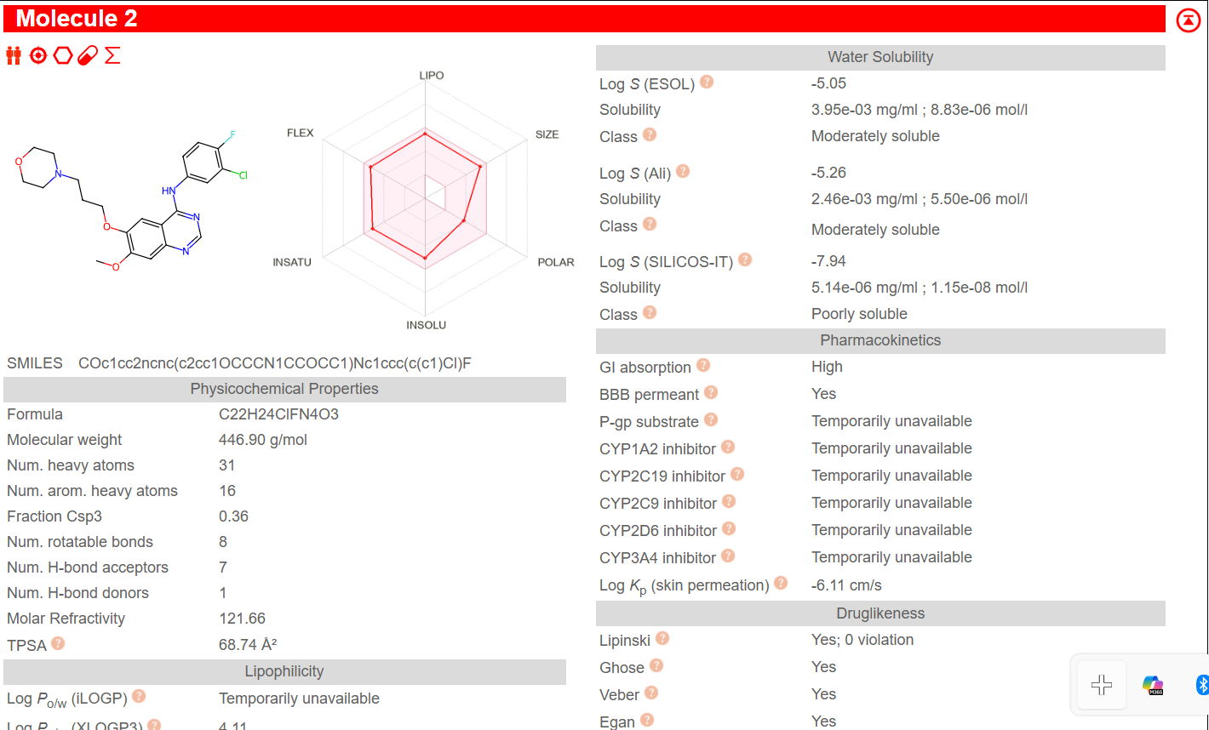
Screenshot 1 — SwissADME Results (Lipinski Scores for All 3 Compounds)
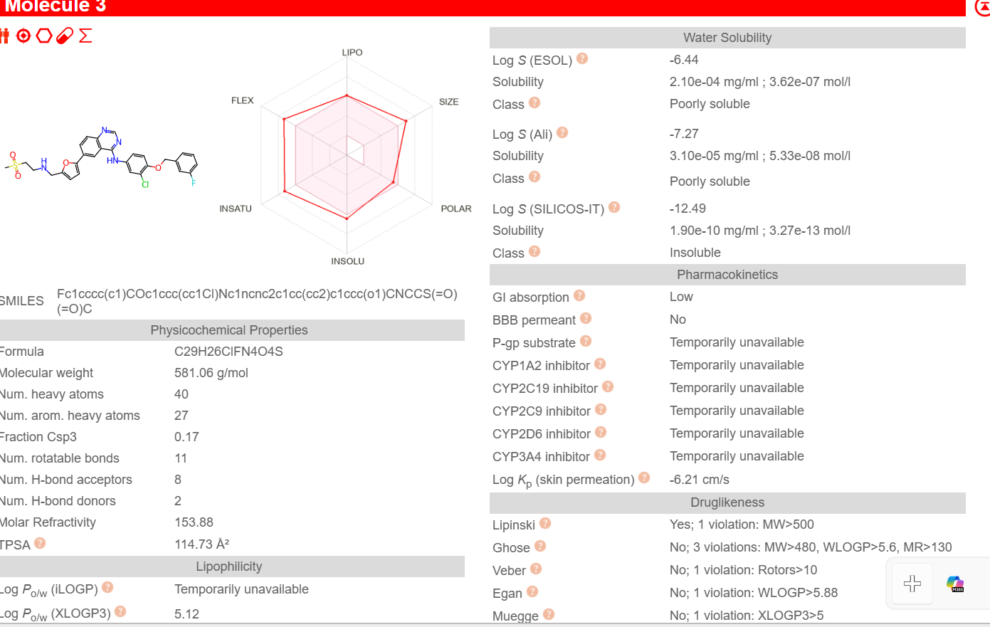
▸ Written Justification
Based on the Lipinski scores, which compound(s) are drug-like? Explain your reasoning. (Write 3–5 sentences below)

Based on the Lipinski scores, the three compounds are drug like. This is because they all obey the Lipinski rule of five. However, compounds 1 and 2 are very druglike with no violations. The last compound, lapatinib still is druglike, but it violated the rule of MW being less than 500 g/mol.

TASK 2 | Molecular Docking & Interactions

Objective: To demonstrate the ability to perform Molecular Docking and visualize protein-ligand interactions.

Prerequisites from Week 1
This task uses: (1) the prepared 1M17 protein from Week 1 Task 3, and (2) the binding site residues from Week 1 Task 2. Ensure you have those files ready before starting.

▸ Task Description
1 | Open PyRx and import your prepared protein (1M17_prepared.pdb from Week 1 Task 3).
2 | Import the SDF files for all three ligands: Erlotinib, Gefitinib, and Lapatinib.
3 | Minimize all ligand structures in PyRx using the energy minimization function.
4 | Define the docking grid box — centre it on the binding site residues identified in Week 1 Task 2.
5 | Run AutoDock Vina for all three compounds against the 1M17 protein.
6 | Record the best docking score (kcal/mol) for each compound from the PyRx results table.
7 | Export the docked poses as PDBQT files.
8 | Open the docked complex in Biovia Discovery Studio (DS). Generate 3D interaction images for each compound.
9 | Use DS to create 2D ligand interaction diagrams for each compound, showing H-bonds, hydrophobic contacts, etc.
10 | Take annotated screenshots of all 3D and 2D interaction images in Discovery Studio.

▸ Deliverable 2A — Docking Scores Table
Fill in the docking results from PyRx below.

Compound | PubChem CID | Best Docking Score (kcal/mol) | Rank
Erlotinib | 176870 | -9.1 | 1st
Gefitinib | 123631 | -8 | 2nd
Lapatinib | 208908 | -7 | 3rd

Tip
More negative docking scores indicate stronger predicted binding affinity. A score more negative than −7.0 kcal/mol is generally considered good.

▸ Deliverable 2B — PyRx Screenshot During Docking
[ Insert Screenshot Here ]
Screenshot 2 — PyRx: Molecular Docking in Progress / Results Panel

▸ Deliverable 2C — Biovia Discovery Studio: 2D Ligand Interaction Diagrams
Note
The 2D diagram maps each interaction type using colour-coded icons. Include all three compounds.

[ Insert Screenshot Here ]
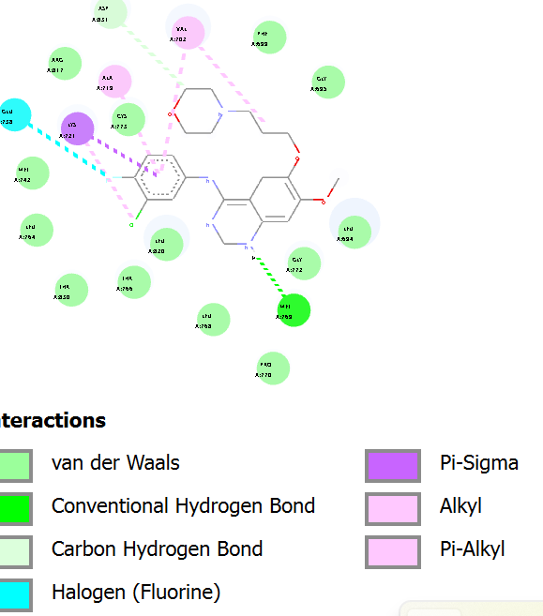Screenshot 3 — 2D Diagram: Erlotinib–1M17 (Discovery Studio)

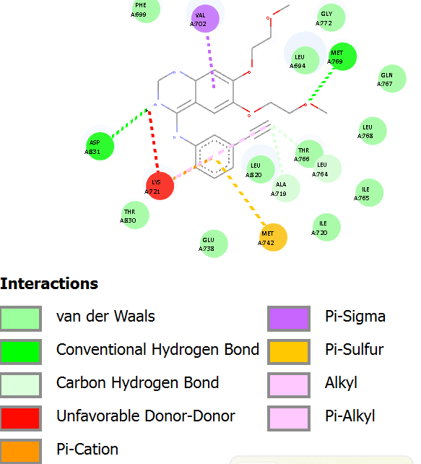[ Insert Screenshot Here ]
Screenshot 4 — 2D Diagram: Gefitinib–1M17 (Discovery Studio)

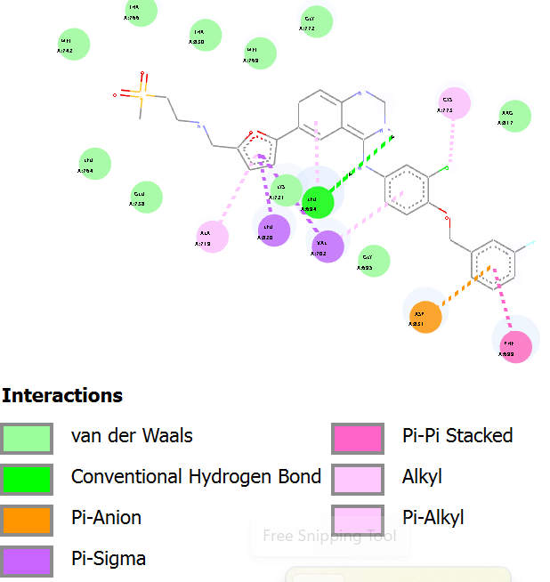[ Insert Screenshot Here ]
Screenshot 5 — 2D Diagram: Lapatinib–1M17 (Discovery Studio)

▸ Written Justification
Compare the docking scores and molecular interactions of all three compounds. Which compound shows the most promising binding? Use evidence from both the scores and the interaction diagrams to support your answer. (Write 4–6 sentences below)

TASK 3 | ADMET Prediction

Objective: To demonstrate the ability to perform ADMET prediction of selected drug candidates using ADMETlab 3.0.

▸ Task Description
1 | Go to ADMETlab 3.0 (https://admetlab3.scbdd.com) and select the 'Prediction' option.
2 | Enter the SMILES strings for all three compounds: Erlotinib, Gefitinib, and Lapatinib.
3 | Run the full ADMET prediction for all three compounds.
4 | From the results, record at least 2 properties for each of the five ADMET categories: Absorption, Distribution, Metabolism, Excretion, and Toxicity.
5 | Take a screenshot of the results page from ADMETlab showing the ADMET summary for all three compounds.
6 | Download the full ADMET report if available.

What to Report.
You need at least 2 properties per category (ADMET), 10 properties minimum in total per compound. Choose the most pharmacologically relevant ones from the ADMETlab output.
▸ Deliverable 3A — ADMET Properties Tables
Fill in the ADMET values from your ADMETlab 3.0 results below.

A | Absorption

Absorption Property | 🌿  Erlotinib | 🌿  Gefitinib | 💊  Lapatinib
Caco-2 Permeability | -4.4444 | -4.911 | -5.304
Human Intestinal Absorption (HIA) | ------- | --------- | ------

D | Distribution

Distribution Property | 🌿  Erlotinib | 🌿  Gefitinib | 💊  Lapatinib
Blood-Brain Barrier (BBB) | ----- | ----- | -----
Plasma Protein Binding (PPB) | 93.9% | 89.4% | 99.0%

M | Metabolism

Metabolism Property | 🌿  Erlotinib | 🌿  Gefitinib | 💊  Lapatinib
CYP1A2 Inhibitor | - | - | +++
CYP2D6 Substrate | -- | +++ | ---

E | Excretion

Excretion Property | 🌿  Erlotinib | 🌿  Gefitinib | 💊  Lapatinib
Half-life (T1/2) | 1.281 | 0.844 | 0.685
Clearance (CL) | 7.612 | 6.422 | 3.811

T | Toxicity

Toxicity Property | 🌿  Erlotinib | 🌿  Gefitinib | 💊  Lapatinib
hERG Inhibition | 0.406 | 0.899 | 0.86
AMES Mutagenicity | 0.347 | 0.608 | 0.763

▸ Deliverable 3B — ADMETlab Screenshot
[ Insert Screenshot Here ]
Screenshot 6 — ADMETlab 3.0 ADMET Results (All 3 Compounds)

▸ Written Justification & Comparison
Compare the ADMET profiles of all three compounds. Which compound has the best overall ADMET profile? Highlight at least 3 specific properties in your comparison and explain what they mean for drug development. (Write 5–7 sentences below)

From the three compounds, erlotinib had the best ADMET properties, as the toxicity, excretion, metabolism and distribution were within the normal range. Lapatinib and gefitinib, the third compound had a high Herg inhibition value and this is not desirable. The AMES mutagenicity was also high with the two compounds. Lapatinib had the highest protein binding. Meaning that it is not easily released from the protein. Erlotinib had the best Caco3 permeability, meaning that it had towards optimal intestinal absorption better than gefitinib and lapatinib.

📣 LINKEDIN PORTFOLIO POST
Week 2 — Required Submission

Important
This is ONE single post combining both tasks. Do NOT create separate posts for each task.

▸ What to Include in Your Post

# | Deliverable | Your Response / Submission
1 | Annotated SwissADME screenshot showing drug-likeness / Lipinski results (Task 1) | Insert your annotated screenshot
2 | One annotated PyRx screenshot during or after molecular docking (Task 2) | Insert your annotated screenshot
3 | One Discovery Studio image highlighting the molecular interaction of the protein with a single ligand (Task 2) | Choose the best-scoring compound
4 | Brief caption for each image explaining what it shows and what you learned | 2–3 sentences per image
5 | Annotated ADMETlab screenshot showing ADMET prediction results (Task 3) | Insert annotated screenshot in your post

▸ Tagging & Hashtags
Tag: @The Insilico Lab

#CADD | #DrugDiscovery | #ComputationalBiology | #VirtualResearch | #TheInsilicoLab | #Chemoinformatics

End of Week 2 Assignment
Good luck! The Insilico Lab Team

